INVESTMENT PLATFORM – PRODUCT OVERVIEW
AI-Driven Financial Learning & Investment Platform
Learn Smart. Practice Safely. Invest with Confidence.

Product Snapshot
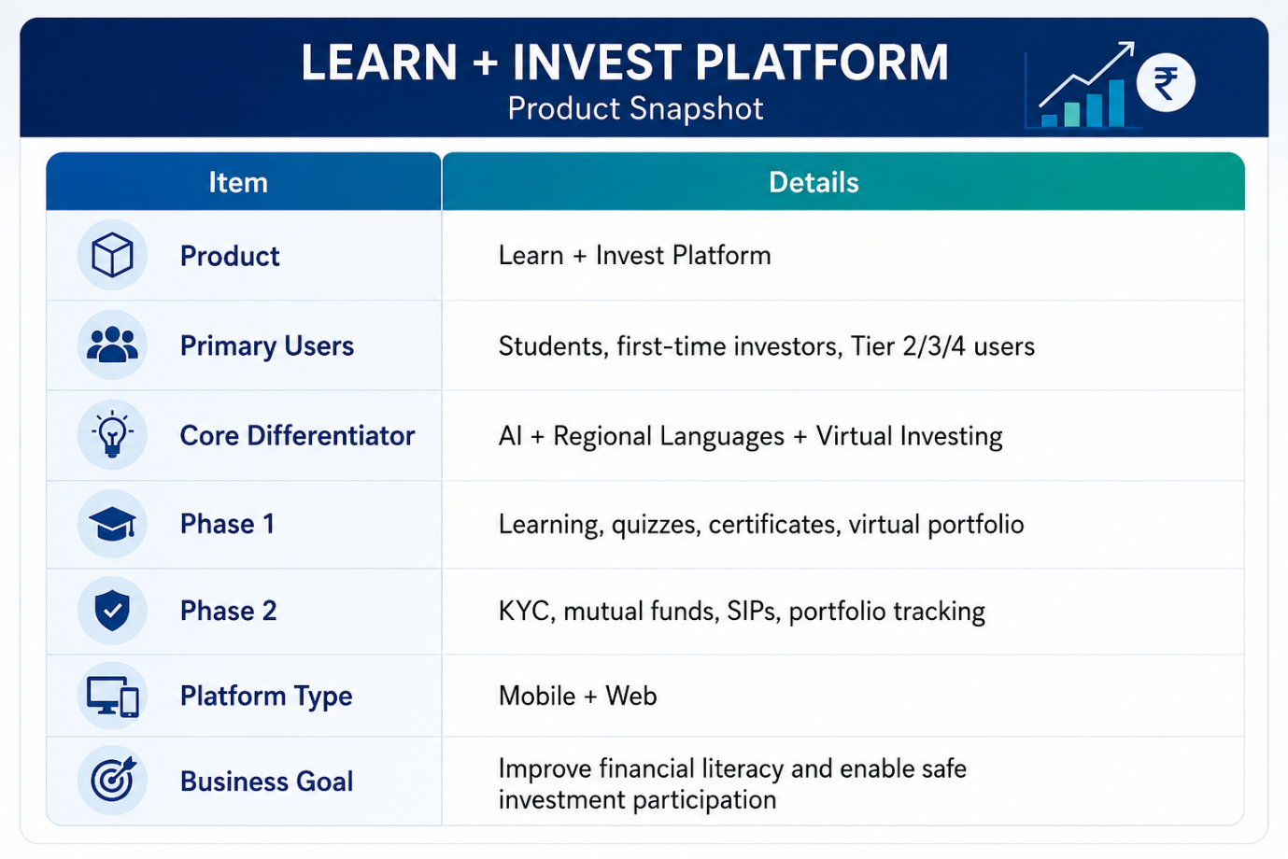

Executive Summary
The Learn + Invest Platform is a proposed fintech solution designed to bridge the gap between financial awareness and investment participation in India. Existing investment applications provide transaction capabilities, but they generally assume that users already understand concepts such as stocks, mutual funds, SIPs, risk management, and portfolio diversification.
This platform follows a learning-first investment model, where users are guided through structured financial education before accessing real investment services. The initial release focuses on regional-language learning, AI-assisted guidance, quizzes, certification, and virtual investment simulation, while future phases introduce mutual fund investment, SIP management, portfolio tracking, and market analytics.
The product is intended for students, first-time investors, and users from Tier 2, Tier 3, and Tier 4 regions of India, where access to reliable financial education remains limited.

The Challenge
Retail investment participation in India is growing rapidly, but a significant number of new investors enter the market without understanding:
- how companies raise capital,
- what shares represent,
- how mutual funds work,
- the difference between investing and trading,
- and the risks associated with market participation.
For many users in smaller towns and rural areas, financial decisions are often influenced by informal advice networks rather than structured financial education. This creates a strong need for a platform that combines education, practice, and investment access within a single trusted ecosystem.

Why Existing Platforms Are Not Enough
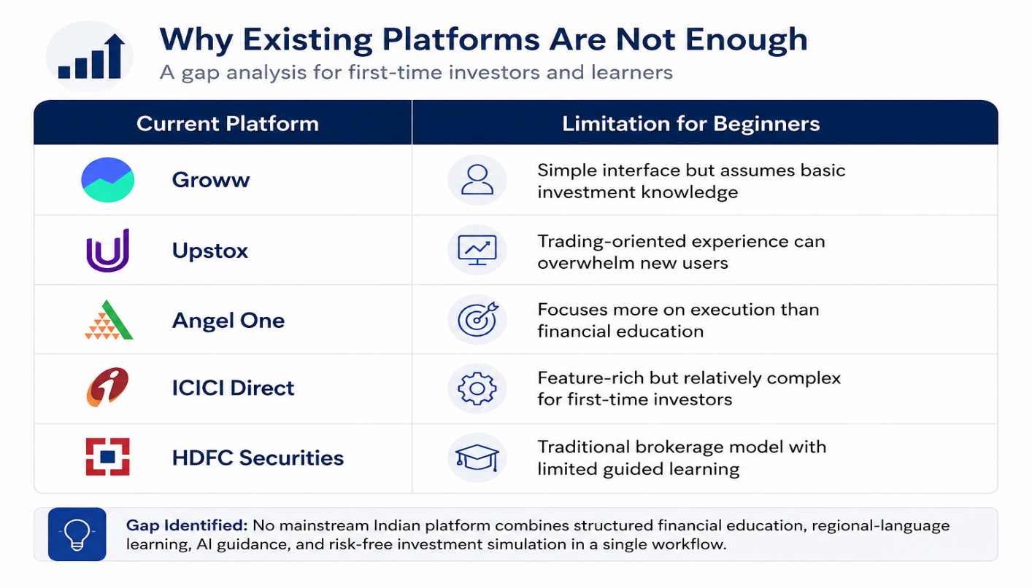
Product Vision
Make investing understandable, accessible, and safe for every Indian user, regardless of language or location.
The platform is designed to become a single ecosystem for learning, practicing, and investing. Users can learn investment concepts, practice with simulated capital, receive AI-assisted guidance, track their progress through assessments and certificates, and gradually transition to regulated investment products such as mutual funds and SIPs.
The emphasis is on building investor confidence through education rather than encouraging speculative trading behavior.
Target Audience
Primary Audience
- Students and fresh graduates
- First-time retail investors
- Small-town and semi-urban users
- Local business owners seeking long-term investment options
Secondary Audience
- Young professionals beginning systematic investing
- Users seeking financial education in regional languages
- Families planning long-term goals such as housing, education, or retirement savings
The platform is intentionally positioned for underserved regional markets rather than experienced active traders.

User Persona
Persona: Ramesh Kumar
Attribute | Details
Age | 24
Location | Nizamabad, Telangana
Occupation | Degree graduate assisting in family business
Financial Goal | Save ₹2,000 per month for future education and family needs
Current Problem | Does not understand SIPs, mutual funds, or market risk
Platform Journey | Learns in Telugu → completes Mutual Fund Basics → practices with virtual ₹1,00,000 → receives SIP education → completes KYC → starts a real SIP
This persona reflects the regional first-time investor segment that the platform is designed to serve.

Solution Overview
The product is planned as a two-phase platform.
Phase 1 – Financial Learning & Simulation
This phase establishes the educational foundation of the platform.
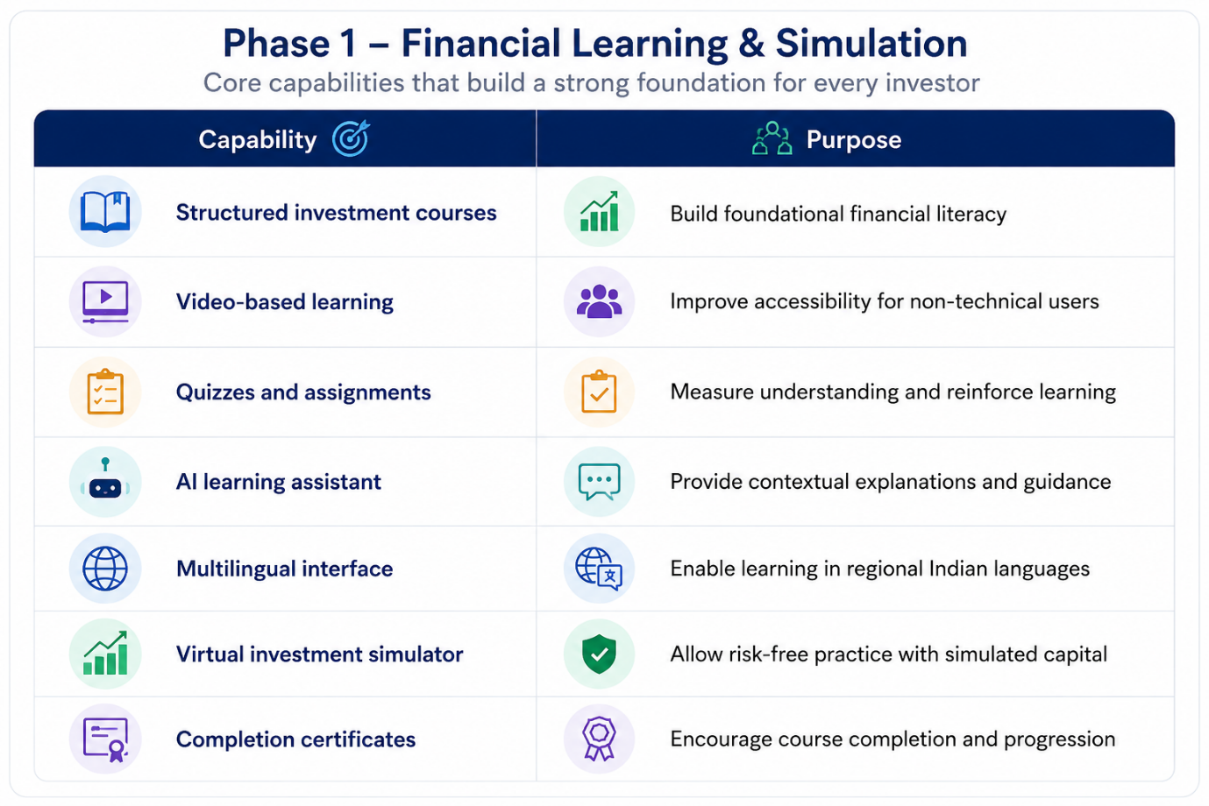Each user receives a virtual ₹1,00,000 balance that can be used to simulate stock and mutual fund transactions. The simulator is intended to develop familiarity with watchlists, portfolio tracking, and investment decision-making without exposing users to financial risk.
Phase 2 – Investment Enablement
After completing the learning flow, users gain access to regulated investment capabilities.
Planned Features
- Mutual fund investment
- SIP creation and management
- Watchlists and market tracking
- Portfolio holdings and performance view
- Investment alerts and notifications
- Basic market analytics and reporting
This phased approach ensures that investment access is introduced only after users have completed the necessary educational journey.

Core Product Capabilities
Financial Learning Engine
The learning engine covers investment fundamentals, including money management, saving vs. investing, stock market basics, mutual funds and SIPs, portfolio diversification, risk and return concepts, and long-term wealth creation principles.
The content is organized into sequenced learning paths rather than isolated lessons, allowing users to progress from beginner concepts to practical investment understanding.
AI Learning Assistant
The AI assistant is designed as an educational support layer, not as an automated investment advisor.
Its responsibilities include:
- answering investment-related questions,
- simplifying financial terminology,
- translating user queries between regional languages and English,
- recommending the next learning module based on user progress,
- and providing contextual explanations for investment concepts.
This creates a single-platform learning experience without requiring users to rely on external AI tools for clarification.
Multilingual Experience
A key differentiator is support for Indian regional languages, enabling users to learn, ask questions, and navigate the platform in their native language. This directly addresses one of the largest adoption barriers in regional fintech markets.

User Journey
The expected user journey is illustrated below.
User Journey
The platform is designed to guide users through a progressive investment-readiness journey rather than providing immediate access to investment products. The objective is to ensure that every user completes learning, assessment, and practice before transitioning to real investment activities.
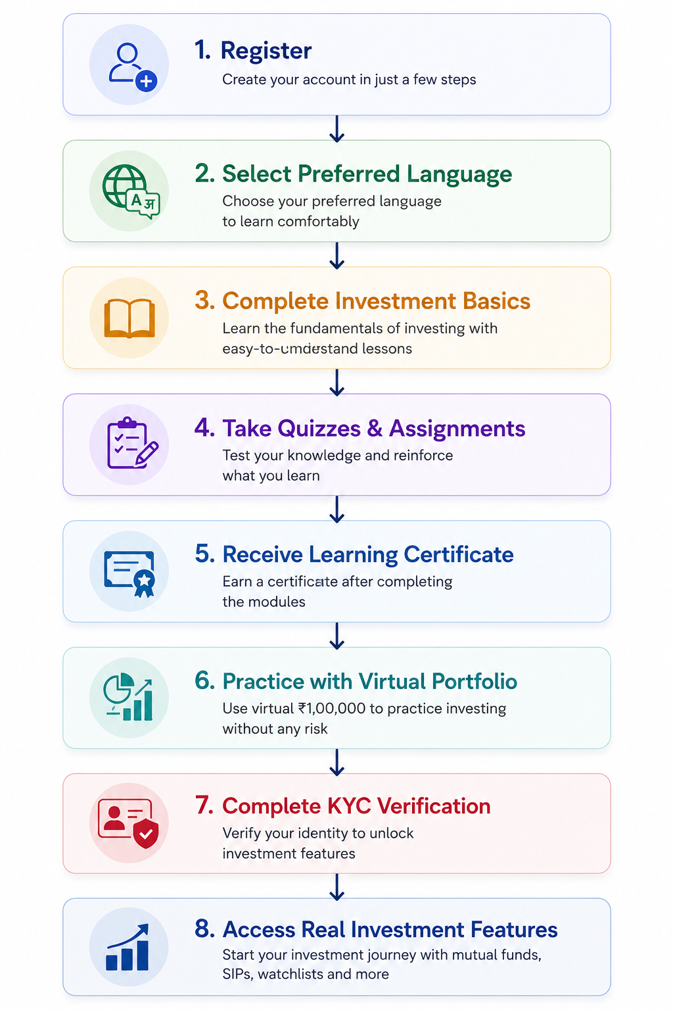
Stage | User Activity | Platform Outcome
Onboarding | Register and choose preferred language | Personalized learning environment
Learning | Complete investment fundamentals | Foundational financial literacy
Assessment | Attempt quizzes and assignments | Knowledge validation
Certification | Successfully complete learning modules | Completion certificate issued
Simulation | Use virtual ₹1,00,000 portfolio | Practical investment experience
Verification | Complete PAN, Aadhaar, and bank verification | Investment-ready account
Investment Access | Enable mutual fund and SIP features | Real investment participation
This workflow ensures that education, assessment, and practice occur before real-money investing is enabled, supporting the platform’s learning-first investment philosophy.

Learning Framework
To improve user retention and investment understanding, the platform proposes a 30-day structured onboarding program.
Week | Focus Area
Week 1 | Financial literacy, money management, saving vs. investing
Week 2 | Stocks, shares, mutual funds, SIPs, and portfolio basics
Week 3 | Watchlists, dashboards, reports, and market navigation
Week 4 | Risk management, goal-based investing, and practical investment planning
The framework is designed to move users through Awareness → Understanding → Practice → Investment Readiness.

Feature Priority Matrix
A phased delivery model helps focus development on the highest-value capabilities first.
Feature | Priority | Phase
User Registration & Authentication | High | Phase 1
Regional Language Support | High | Phase 1
AI Learning Assistant | High | Phase 1
Virtual Portfolio Simulator | High | Phase 1
Quizzes & Certificates | High | Phase 1
Community Discussion | Medium | Phase 1
Mutual Fund Investment | High | Phase 2
SIP Management | High | Phase 2
Portfolio Tracking | High | Phase 2
Advanced Analytics | Medium | Phase 3
IPO Investment | Low | Future
This prioritization supports incremental delivery while focusing on user trust, education, and engagement before monetized investment features.

Technology Architecture
The platform follows a mobile-first, cloud-native architecture designed for scalability, real-time market data handling, and future fintech expansion.
High-Level Architecture
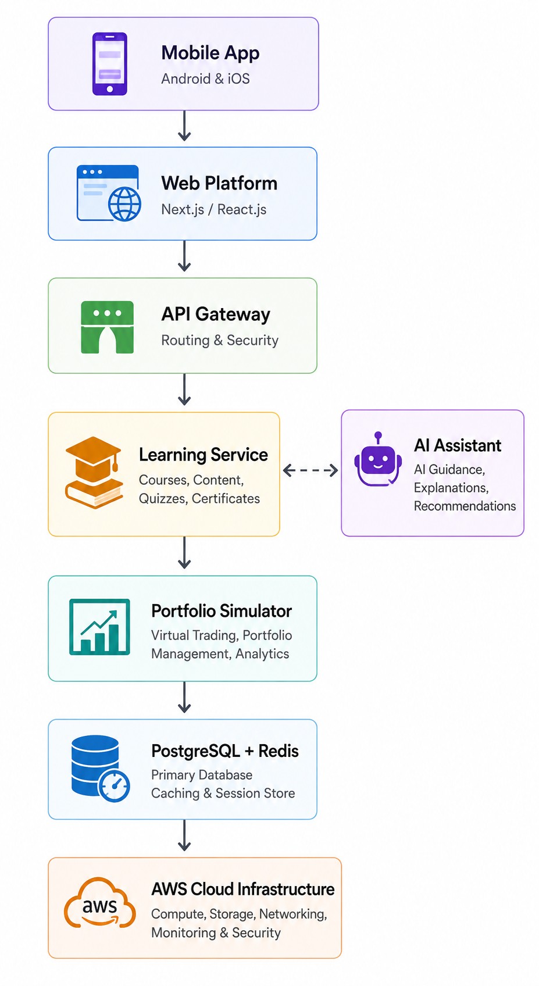

Client Layer
- React Native for Android and iOS applications
- Next.js / React.js for the web platform
- TypeScript for maintainable frontend development
Service Layer
- Node.js APIs for core application services
- Spring Boot microservices for scalable backend operations
- FastAPI services for AI and analytics workloads
- JWT-based authentication and authorization
Data & Infrastructure Layer
- PostgreSQL for transactional and user data
- MongoDB for flexible content and community data
- Redis for caching and session management
- Kafka for real-time event streaming
- AWS cloud infrastructure
- Docker & Kubernetes for container orchestration and deployment automation
The architecture is designed to support real-time market updates, scalable learning services, AI workloads, portfolio simulation, and future investment operations.

Compliance & Security
Because the platform operates in the financial services domain, compliance and security are treated as core platform requirements rather than optional enhancements.
Regulatory Alignment
- SEBI-compliant investment workflows
- KYC and AML verification processes
- PAN and Aadhaar integration
- DigiLocker-based identity verification
- User consent and risk-disclosure management
Security Controls
- JWT-based authentication
- Multi-factor authentication (MFA)
- OTP-based verification
- Encrypted API communication
- Role-based access control (RBAC)
- Secure cloud infrastructure and data storage
Investment Disclaimer
The platform must clearly communicate that:
- Mutual funds are subject to market risk.
- AI-generated insights are educational in nature.
- Users should make independent investment decisions based on their financial goals and risk tolerance.
This approach ensures that the platform remains education-focused and compliance-aware, reducing the risk of users interpreting AI guidance as personalized financial advice.

Competitive Positioning
The product is positioned as an investment enablement platform rather than a traditional brokerage application.
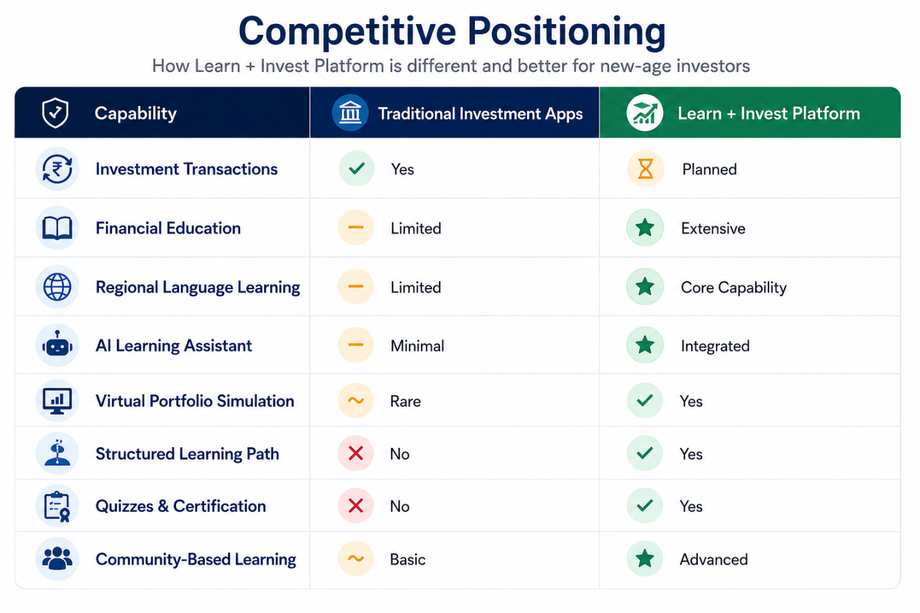Strategic Differentiator
AI-powered financial education combined with regional-language accessibility and risk-free investment simulation.
This positioning allows the product to compete not only on transaction capability, but on investor readiness, financial literacy outcomes, and long-term user trust.
Success Metrics
To evaluate product effectiveness, the platform should track learning, engagement, conversion, and investment-readiness metrics rather than transaction volume alone.
Category | KPI
User Adoption | Registered users, monthly active users (MAU)
Learning Outcomes | Course completion rate, quiz pass percentage
Engagement | Average daily learning time, AI queries per user
Trust Building | Percentage of users completing virtual portfolio practice
Conversion | Users progressing from learning modules to KYC onboarding
Investment Readiness | SIP activation rate and mutual fund onboarding (future phase)
These KPIs align product success with financial literacy improvement and responsible investment participation.

Business Value
Value for Users
The platform provides:
- Structured financial education for beginners.
- Risk-free investment practice using simulated capital.
- Native-language accessibility for regional users.
- Goal-based learning pathways that simplify complex financial concepts.
- Confidence before investing real money, reducing the likelihood of uninformed investment decisions.
Value for the Business
The proposed model creates long-term strategic value through:
- access to a large underserved regional market,
- higher user retention through learning engagement,
- opportunities for subscription, certification, and investment-service revenue,
- and the foundation for a trusted fintech ecosystem that can expand into additional financial products over time.

Risks & Responsible AI
Because the platform combines AI, financial education, and investment workflows, responsible usage and governance are critical.
Key Risks
Risk | Mitigation
Users treat AI suggestions as financial advice | Mandatory educational disclaimers
Regulatory non-compliance | SEBI consultation and periodic compliance reviews
Misunderstanding of market risks | Structured mandatory learning modules
Data security concerns | Encryption, MFA, secure cloud infrastructure
Low adoption in rural markets | Regional-language onboarding and simplified UX
Responsible AI Principles
The platform follows these principles:
- AI provides educational assistance, not personalized financial advice.
- Investment suggestions remain advisory and non-binding.
- Users must acknowledge market-risk disclosures before accessing investment features.
- Sensitive financial and identity data is protected through encryption, RBAC, and secure cloud infrastructure.
This ensures that AI remains a decision-support tool rather than an automated investment decision-maker.

Product Roadmap
The platform is planned as a phased rollout, prioritizing education and trust-building before introducing advanced investment capabilities. 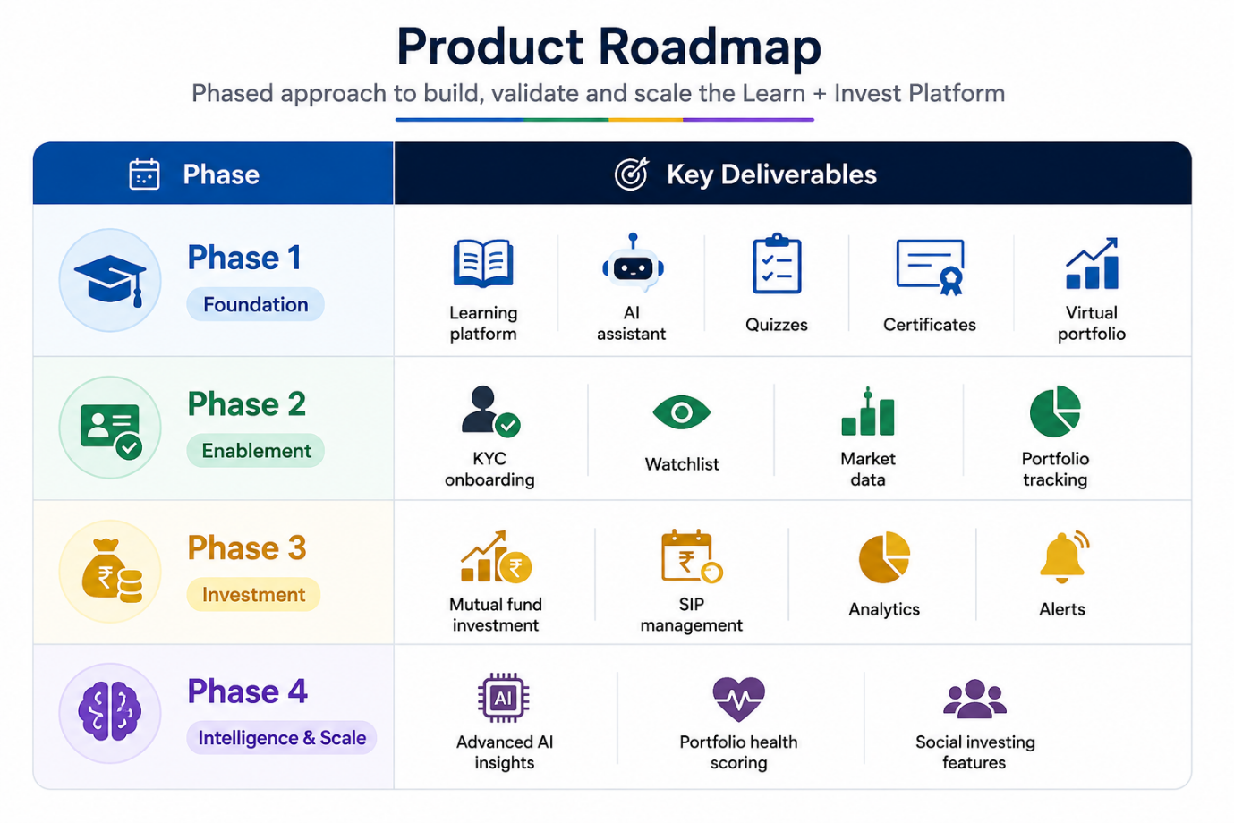
This roadmap supports incremental delivery, user validation, and controlled expansion into regulated investment services.

Future Expansion Opportunities
Short-Term Enhancements
- Additional regional language support
- Financial calculators (SIP, EMI, goal planning)
- Advanced quiz and assessment engine
- Investment glossary with AI-powered explanations
Medium-Term Enhancements
- Goal-based investment planning
- Personalized SIP reminders
- Portfolio health scoring
- Family investment and savings accounts
- AI-powered learning recommendations based on user behavior
Long-Term Vision
- Integration with government financial literacy and skilling initiatives
- Cross-platform investment and certification ecosystem
- Aggregated market-learning insights for curriculum improvement
- Personalized long-term wealth-planning assistance for regional investors

Elevator Pitch
Learn + Invest is an AI-powered financial learning and investment platform designed for India’s next generation of retail investors. It enables users to learn investing in their native language, practice with virtual money, receive AI-assisted guidance, and gradually transition to regulated mutual fund investments through a safe, education-first workflow.
This positioning differentiates the product from traditional brokerage applications by focusing on investor readiness rather than transaction execution alone.

Conclusion
The Learn + Invest Platform addresses a critical challenge in the Indian fintech ecosystem: investment products are becoming accessible faster than investment knowledge is becoming widespread.
By combining structured financial education, AI-assisted multilingual learning, virtual portfolio simulation, and future mutual fund investment capabilities, the platform creates a practical pathway from financial awareness to responsible investment participation.
The platform’s strongest differentiator is not simply its ability to enable transactions, but its ability to prepare new investors to understand what they are investing in, why they are investing, and how to participate in financial markets with greater confidence and lower risk.
This approach positions the product as a scalable financial empowerment platform for regional India, capable of improving financial literacy while creating a trusted foundation for future investment services.

